
Manual for the

KENTMASTER
Stimulation device
Type KEST-3
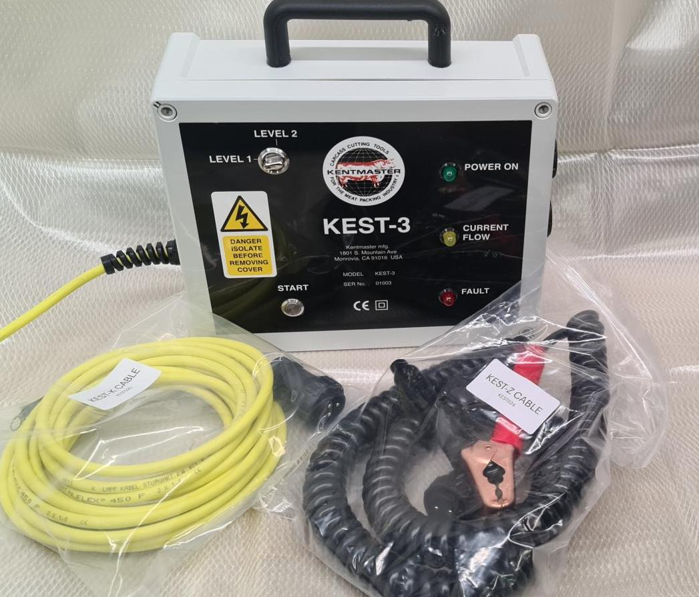
www.kentmaster.com Date 06/2024

O. Warning and user instructions
The operator has to observe national regulations and laws regarding safety and animal welfare, e.g. directive 1099/2009/EC.
Installation, putting into operation and use of the stimulation device has to be done by qualified and instructed persons only.
Use stimulation device for stimulation of animals for slaughter only.
Seperate stimulation transformer from mains supply before starting any maintenance.
Do not combine part of the equipment with part of any equipment from another manufacturer, as we assume no liability for safe use in this case!
Recommendation: When sending the stimulation equipment to manufacturer for repair or maintenance, please use the original packing material, which guarantees safe transport!
Therefore, please store carefully the packing material.

1. Introduction
The stimulation equipment KEST-3 consist of:

- Stimulation transformer type KEST-T
- Stimulation tongs type KEST-Z
- Stimulation cable type KEST-K
Only use these parts together.

2. Technical instruction
2.1. Stimulation transformer KEST-T
The stimulation transformer is built-in a splash proof plastic housing.
Control elements and signals:
 | green signal LED POWER ON: | indicates readiness for operation
 | yellow signal LED CURRENT FLOW ON: | stimulation tension is switched on KEST-Z and KEST-K
 | red signal LED FAULT: | overload or overcharge
 | push button START: | starts or interrupts the stimulation procedure
 | selector LEVEL 1/ LEVEL 2 | selection of the stimulation duration level 1 = approx.45 sec, level 2 = approx-90 sec

2.2. Installation
By trained persons only according to regulation in effect!
Mains supply: | 230V AC
Frequency: | 45 — 60 Hz
2.3. Bringing into service
By trained staff only!
1 . Connect stimulation tongs KEST-Z (upper socket, plus pole) and the stimulation cable KEST-K (lower socket, minus pole) to the sockets on the side of the housing of the stimulation transformer.
- Connect stimulation cable EST-K e.g. to the tube track or the bleeding table.
- Connect stimulation transformer to mains. Green LED MAINS flashes. Stimulation device is ready for use. Red LED FAULT flashes in case of overload, it will lapse after fixing the cause of the malfunction.
Safety fuse (500mA, delay-action) inside the device has to be checked, if green LED does not shine if stimulation transformer is connected to mains supply. Open device and change the safety fuse against attached replacement one.

2.4. Cleaning and maintenace work
By trained staff only!
Clean stimulation devise KEST-3 after use and check it for any damages. Store it in a dry area.
Important: Do not use high pressure for cleaning. Use neutral cleanser only.
Change immediately defective or worn-out parts to guarantee safe use.
Use original spares only.
Maintenance work on the electronic should only be done by the manufacturer

3. Operation instructions
 Stimulation tongs KEST-Z have to be free from electricity when they are connected to the animal. Yellow LED may not shine.
Connect stimulation cable KEST-K e.g. to the tube track or the bleeding table. Two different stimulation durations can be selected, level 1 (approx... 45 sec) or level 2 (approx... 90 sec).
Connect stimulation tongs KEST-Z e.g. to the muzzle of the animal for slaughter.

3.1. Bleeding stimulation
Attention: The stimulation tension is switched on KEST-Z and KEST-K after pressing start button ON/OFF. Excitations of the animal may occur. Keep away from the danger zone
Choose the duration of the stimulation time by putting selector to LEVEL 1 (45 sec) or LEVEL 2 (90 sec). Other durations can be set after consultation with the manufacturer.
Place the stimulation tongs e.g. to the muzzle of the animal for slaughter, press the start button ON/OFF, the yellow current flow LED ON indicates the current flow.
The stimulation device cuts off automatically the stimulation tension at the end of the selected duration. The yellow LED lapses and you can remove the stimulation tongs. You may interrupt the stimulation process by pressing the start button ON/OFF.

4. Technical Data
Measurements: | 300 x 300 x 120 mm (H x W x D)
Weigt: | approx. 3.0 kg
Mains supply: | 230 VAC
Mains frequency: | 45 - 60 Hz
Stimulation tension: | max. ca. 60 V
Stimulation frequency: | max. ca. 100 Hz
Duration of stimulation: | Level 1: max. approx. 45 sec  Level 2: max. approx. 90 sec

Duty ratio:70%



